**REPORT-WEB (RESIT)**

**KRITAGYA JUNG ADHIKARI**

**NILE ID- 16418536**

**GITHUB LIVE URL-** [**https://alphanumeric14.github.io/csy1018re/**](https://alphanumeric14.github.io/csy1018re/)

**SUBMISSION DATE- 14TH JULY, 2017**

**COMMITS AVAILABLE IN- https://github.com/Alphanumeric14/csy1018re**

**CONTENTS**

1. **WIREFRAMINGS**
2. **WORKING WITH HTML AND CSS**

* **INDEX PAGE**
* **COLLECTION PAGE**
* **BIO PAGE**
* **CONTACT PAGE**

1. **VALIDATIONS**
2. **TIME FACTOR AND LIMITATIONS**
3. **CONCLUSION**

**WIREFRAMINGS**

**WIREFRAME-1 (INDEX PAGE)**

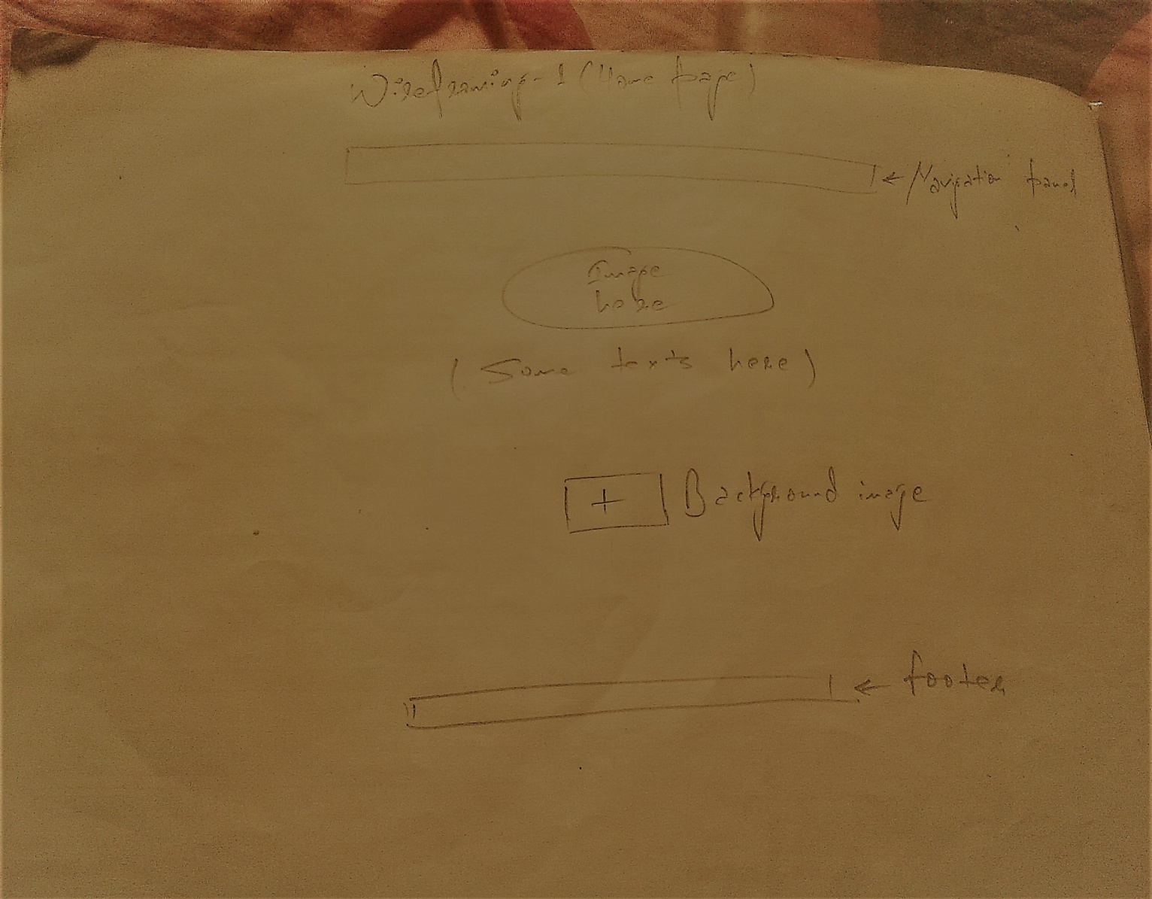

**WIREFRAME-2 (BIO PAGE)**

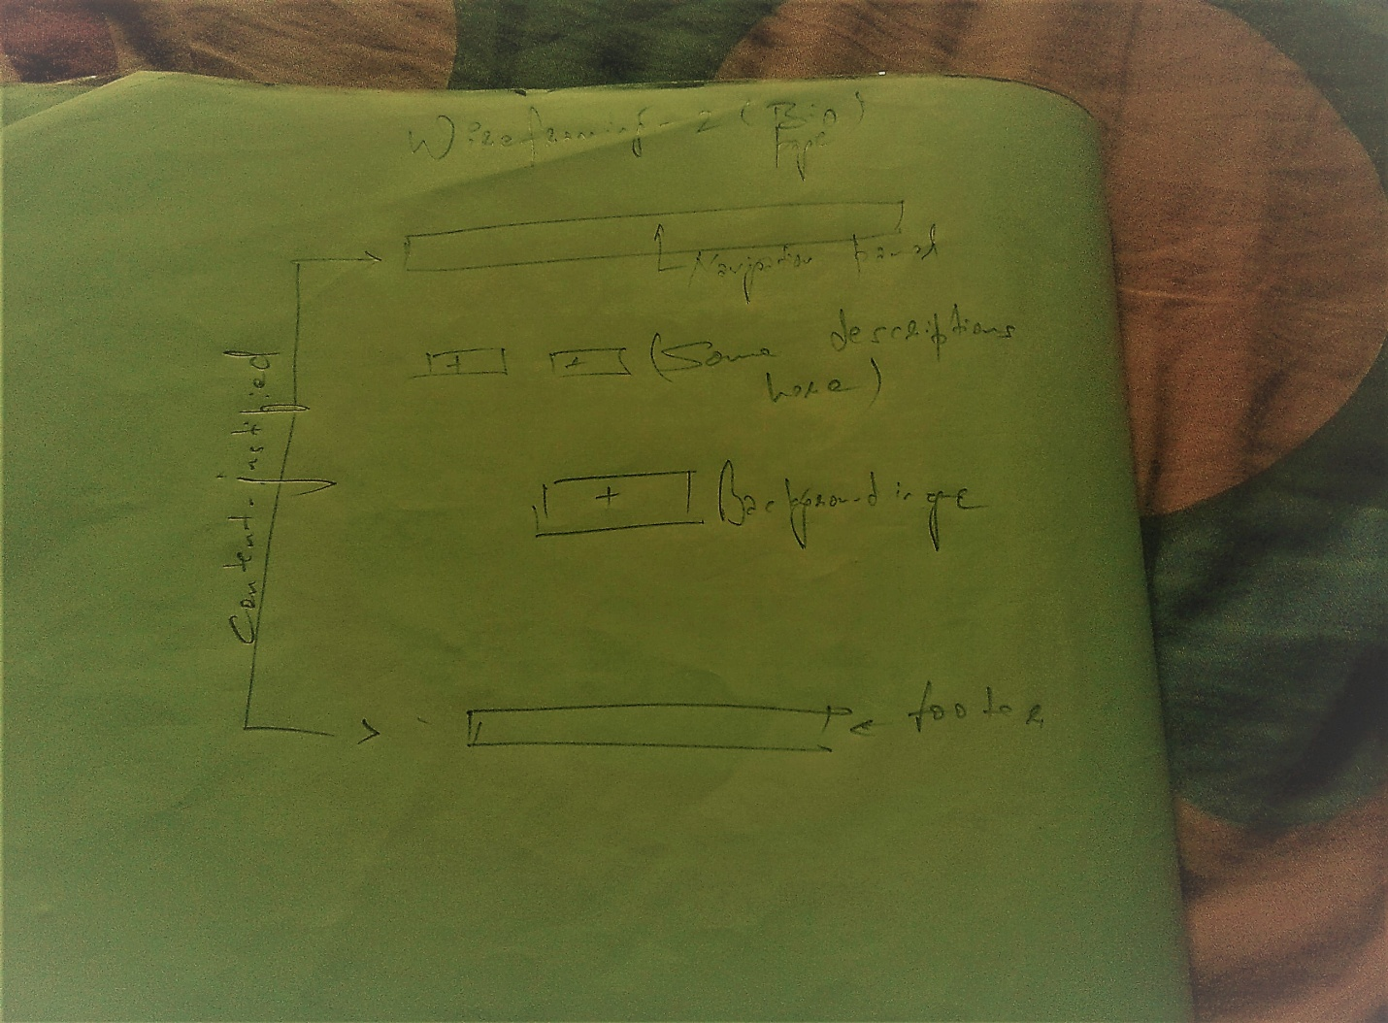

**WIREFRAME-3 (COLLECTION PAGE)**

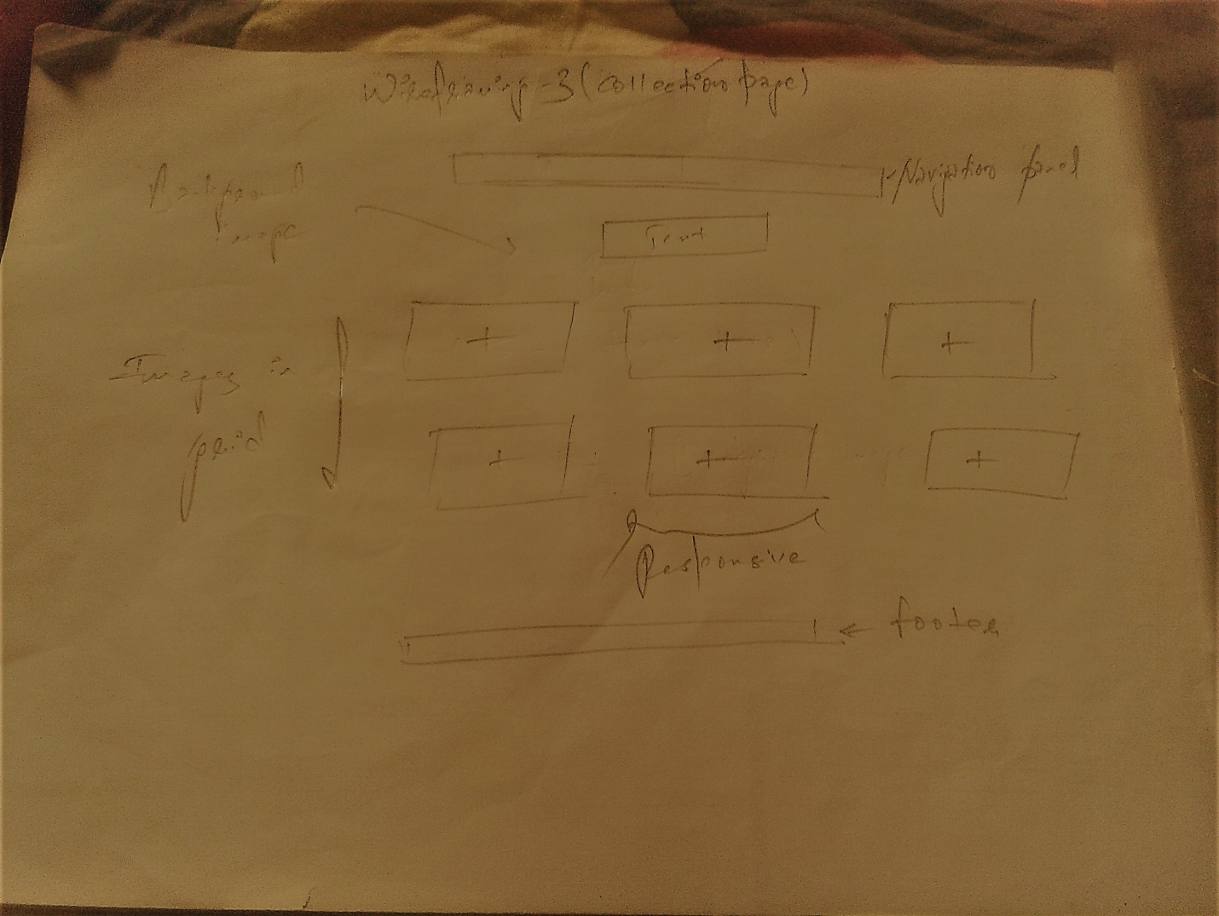

**WIREFRAME-4 (CONTACT PAGE)**

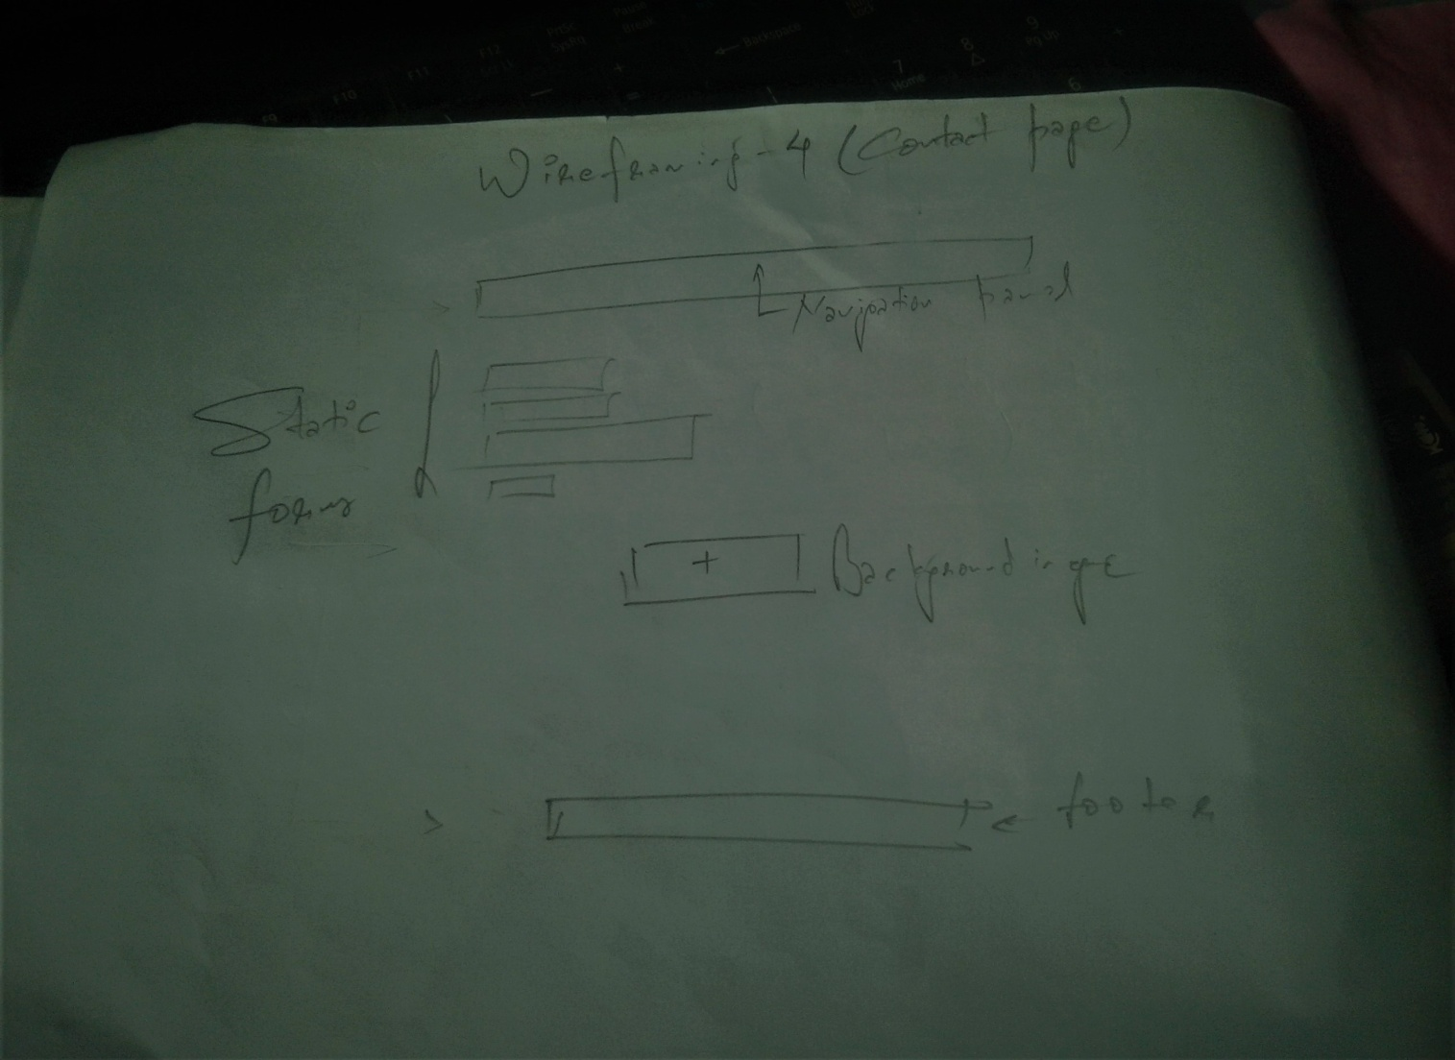

**WORKING WITH HTML AND CSS**

***INDEX PAGE***

***GITHUB URL- https://alphanumeric14.github.io/csy1018re/index.html***

ALSO REFERRED TO AS A HOME PAGE, THIS PAGE IS A ROOT TO ALL THE SUB PAGES. HEADER AND FOOTER WERE DEFINED WITH A FLEX PROPERTY WHICH GAVE A SAME THEME TO ALL THE SUB PAGES. IN THIS PAGE CERTAIN GOOGLE API FONTS AND COLOR DERIVED FROM COLOR-HEX ARE USED. AN OPENING IMAGE WHICH IS LYING JUST BELOW HEADER IS TRANSFORMED INTO CIRCLE BY SETTING BORDER RADIUS TO 50%. A BACKGROUND IMAGE IS DOWNLOADED FROM COPYRIGHT FREE IMAGE SITE PIXABAY. THIS PAGE IS RESPONSIVE AND CAN BE MAINTAINED TO A DEGREE DEFINED BY MAX WIDTH. PADDING AND MARGIN LEVEL ARE EXPLICATED IN ACCORDANCE TO A CHROME DEFAULT VALUE.

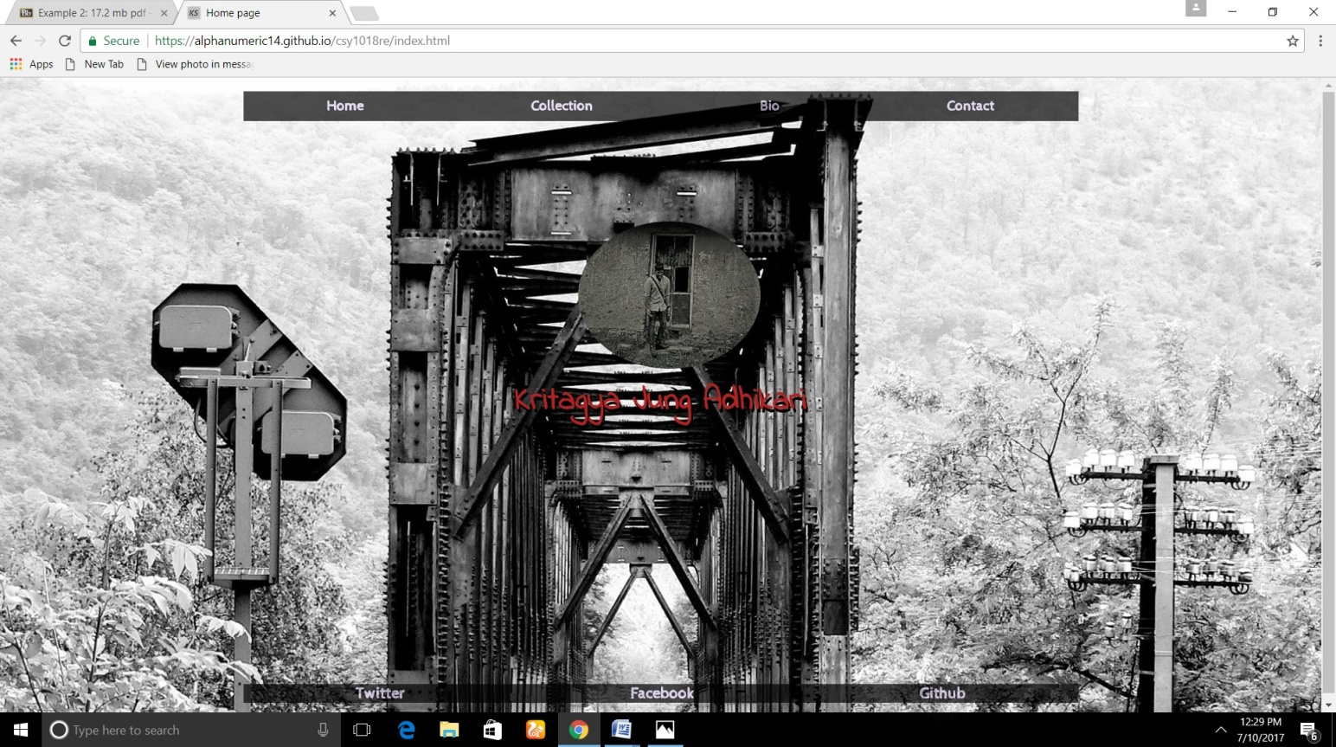

**COLLECTION PAGE**

***GITHUB URL-*** [***https://alphanumeric14.github.io/csy1018re/collection.html***](https://alphanumeric14.github.io/csy1018re/collection.html)

THIS PAGE CONTAINS SOME IMAGES SEQUENCED IN GRID FORMAT. HEADER AND FOOTER ARE IDENTICAL TO INDEX PAGE AND ARE RESPONSIVE IN NATURE. FAVICON WHICH IS DESIGNED WITH THE HELP OF MS-WORD AND PAINT IS SAME FOR ALL OF THE PAGES SO APPLIED TO COLLECTION PAGE. BACKGROUND IMAGE IS DOWNLOADED FROM COPYRIGHT FREE IMAGE CONTRIBUTING SITE PIXABAY. ALL OF THE PHOTOS IN THIS PAGE WERE CAPTURED AND EDITED WITH SELF POTENTIAL AND THE OWNERSHIP OF THESE IMAGES IS PROHIBITED TO OTHER USERS.

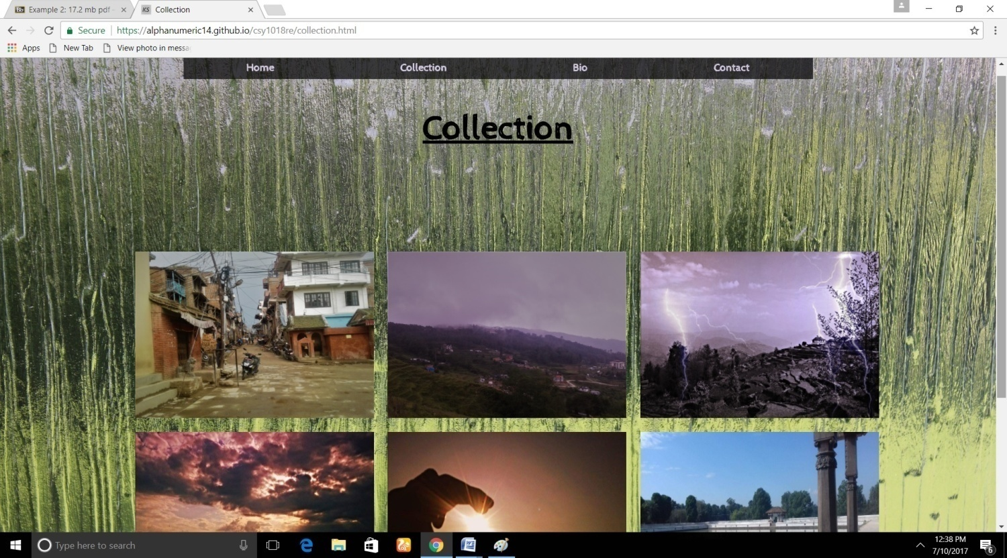

**BIO PAGE**

***GITHUB URL-*** [***https://alphanumeric14.github.io/csy1018re/bio.html***](https://alphanumeric14.github.io/csy1018re/bio.html)

THIS PAGE CONTAINS SHORT DESCRIPTION OF THE IMAGES IN A COLLECTION PAGE. THE STYLE OF THE PAGE IS IDENTICAL TO INDEX PAGE. CERTAIN GOOGLE API FONTS SUCH AS CABIN SKETCH AND SCHEHERAZADE ARE USED. BACKGROUND IMAGE IS DOWNLOADED FROM PIXABAY. THE TEXTS ARE JUSTIFIED WHICH IS ACCENTUATING RESPONSIVE FEATURES. OPACITY PROPERTY IS DEFINED TO MAKE ITEMS LESS VISIBLE THAN DEFAULT WITH RESPECT TO BACKGROUND. THIS FEATURE IS USED IN ALL OF THE PAGES. COLORS ARE DERIVED FROM COLOR-HEX.

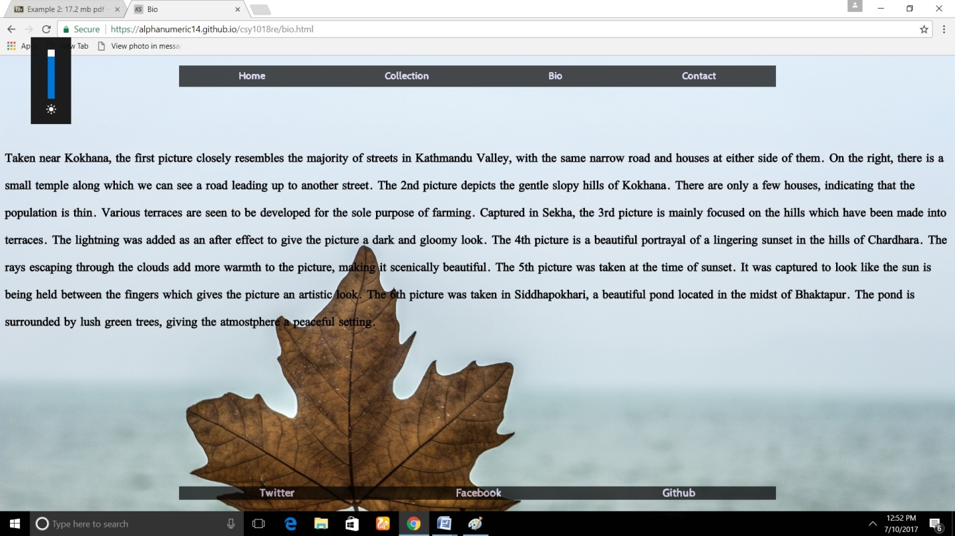

**CONTACT PAGE**

***GITHUB URL-*** [***https://alphanumeric14.github.io/csy1018re/contact.html***](https://alphanumeric14.github.io/csy1018re/contact.html)

THIS PAGE IS DESIGNED TO REFLECT TYPICAL CONTACT PAGE IN WHICH STATIC FORM IS DEVELOPED. CERTAIN BOX SHADOW AND BORDER PROPERTY ARE USED TO SHAPE THE BOX. HOVER PROPERTY IS THE SAME AS USED IN FRONT PAGE AND FEATURES WEBKIT TRANSFORM PROPERTY AS A SUB POINT. THIS PROPERTY IS USED TO ENLARGE THE ITEMS WHEN CURSOR IS ABOVE IT.

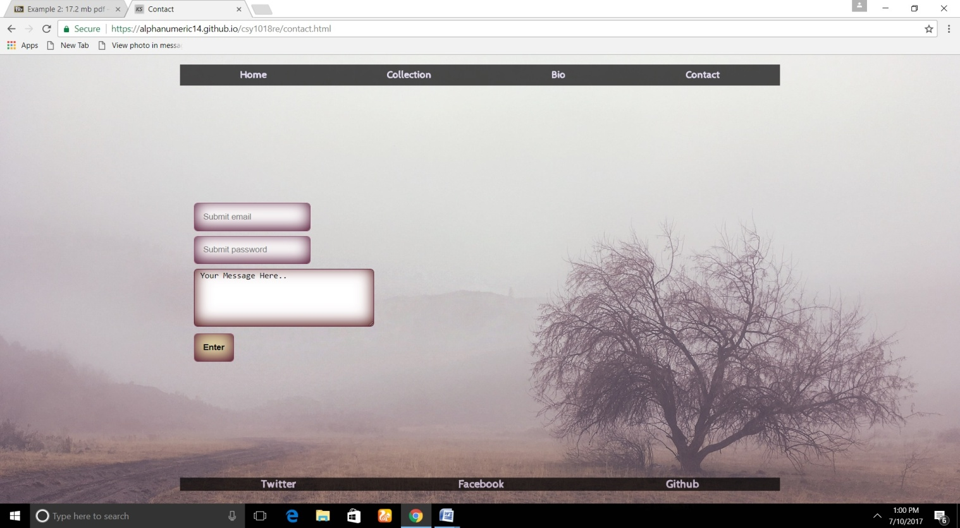

**VALIDATIONS**

***INDEX.HTML VALIDATOR***

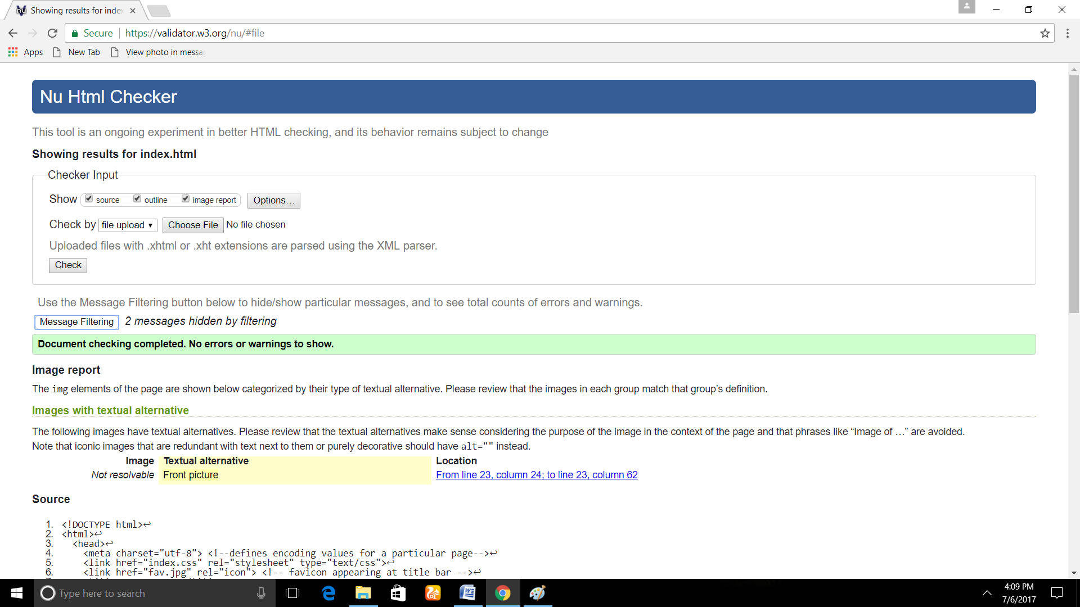

***INDEX.CSS VALIDATOR***

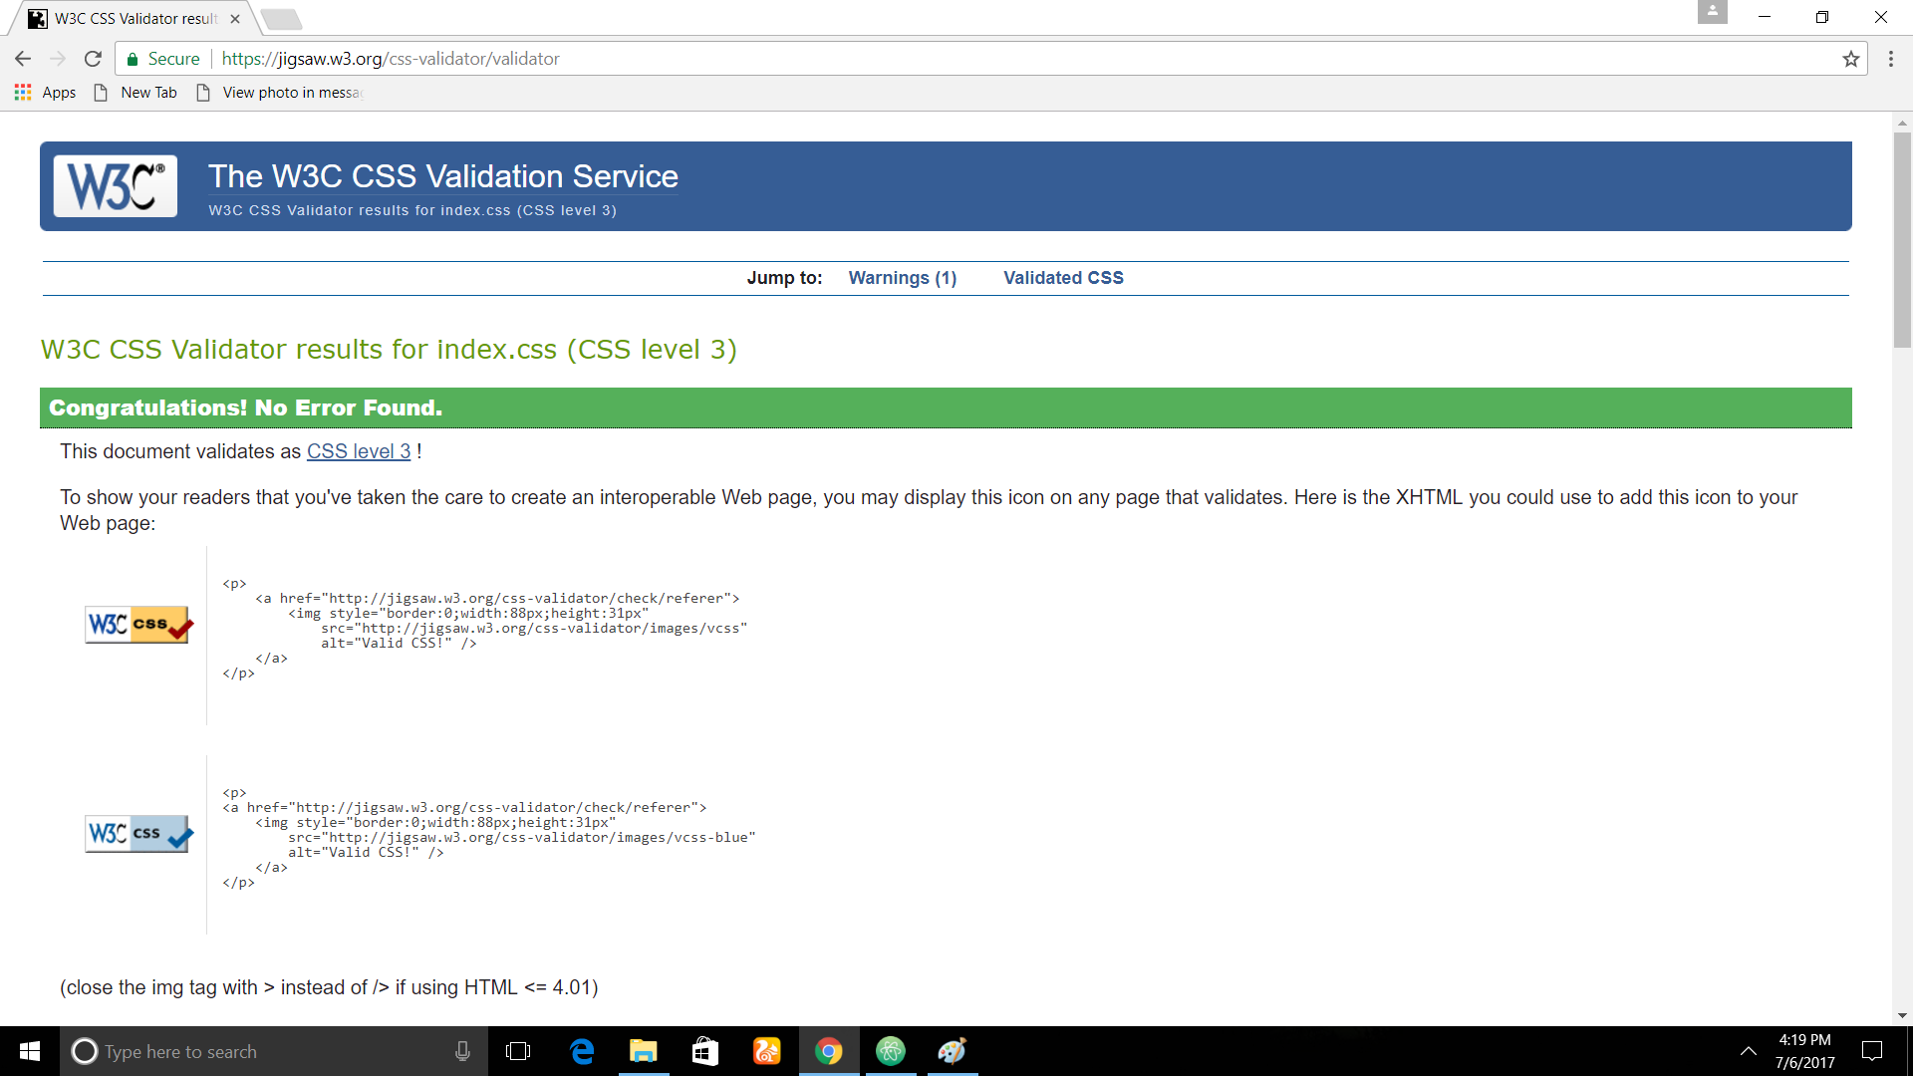

***COLLECTION.HTML VALIDATOR***

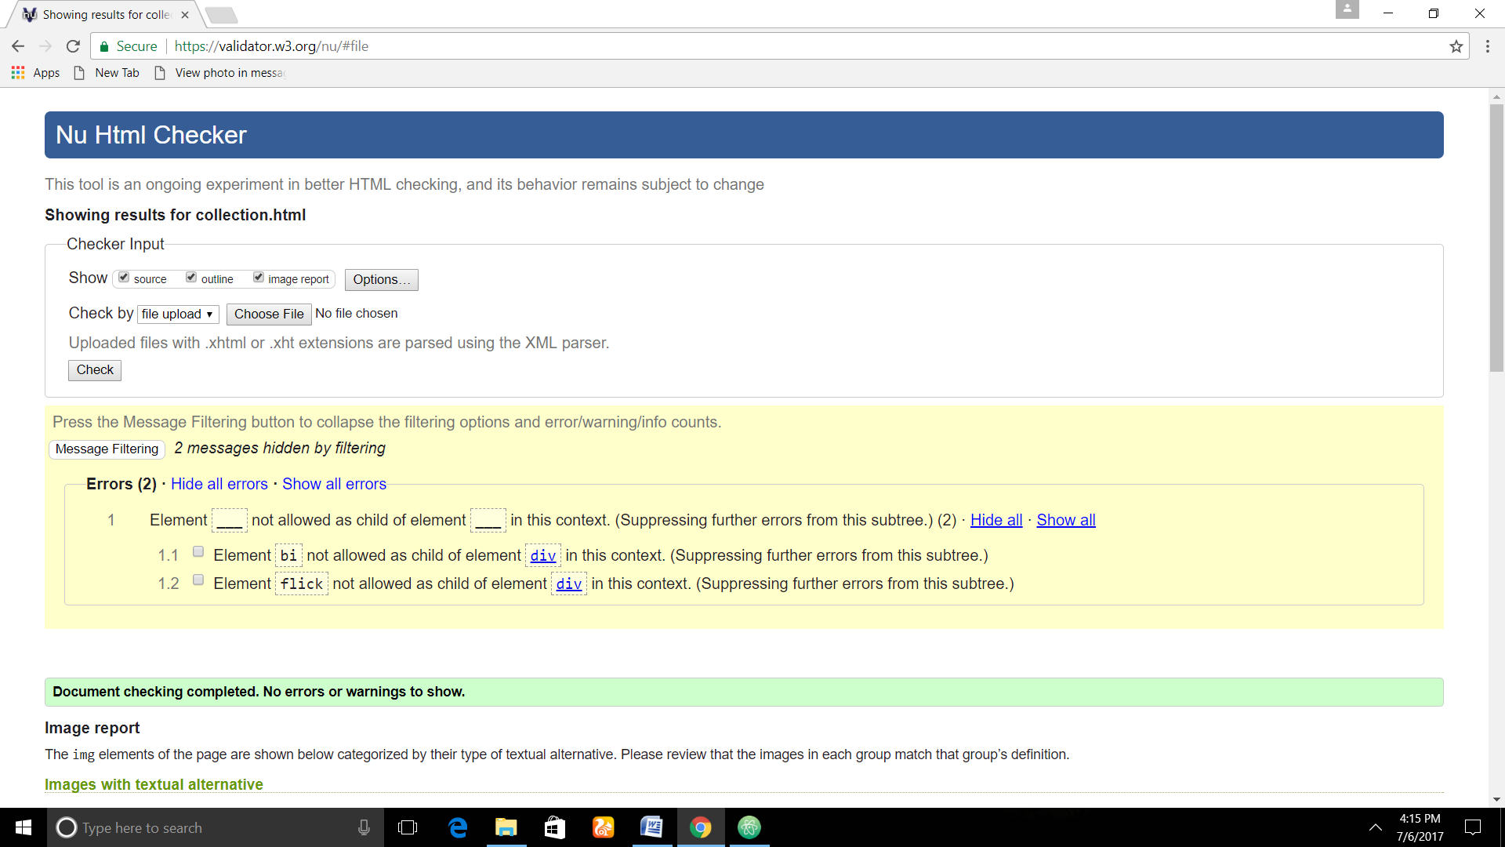

***COLLECTION.CSS VALIDATOR***

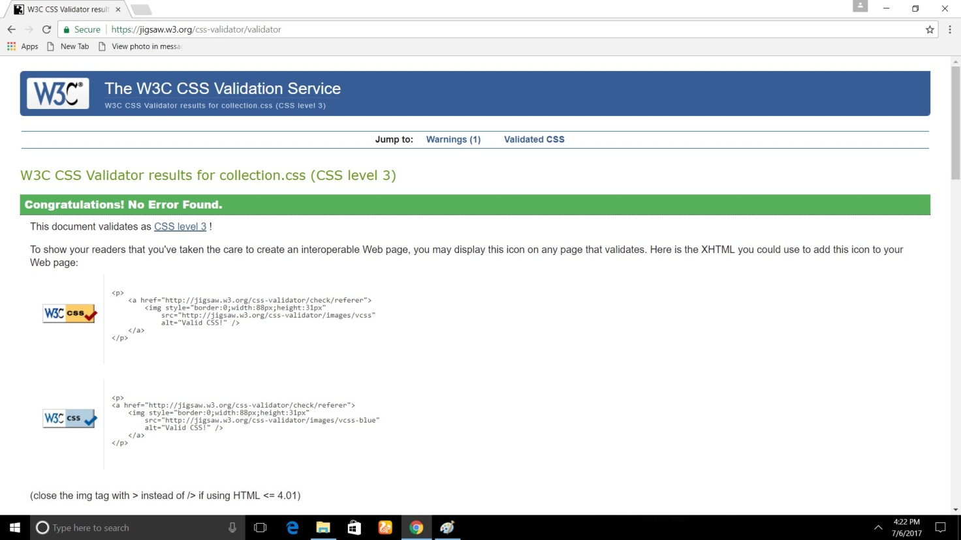

***BIO.HTML VALIDATOR***

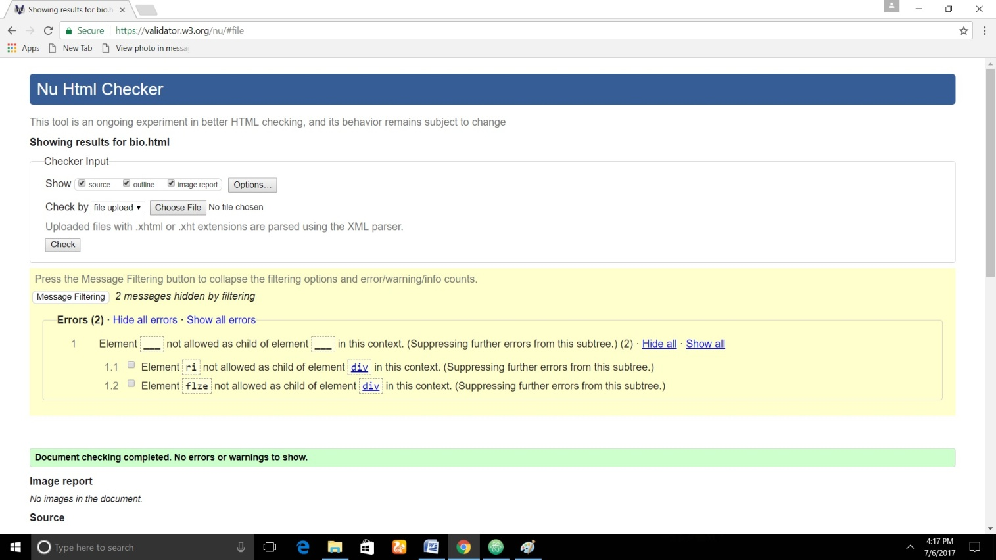

***BIO.CSS VALIDATOR***

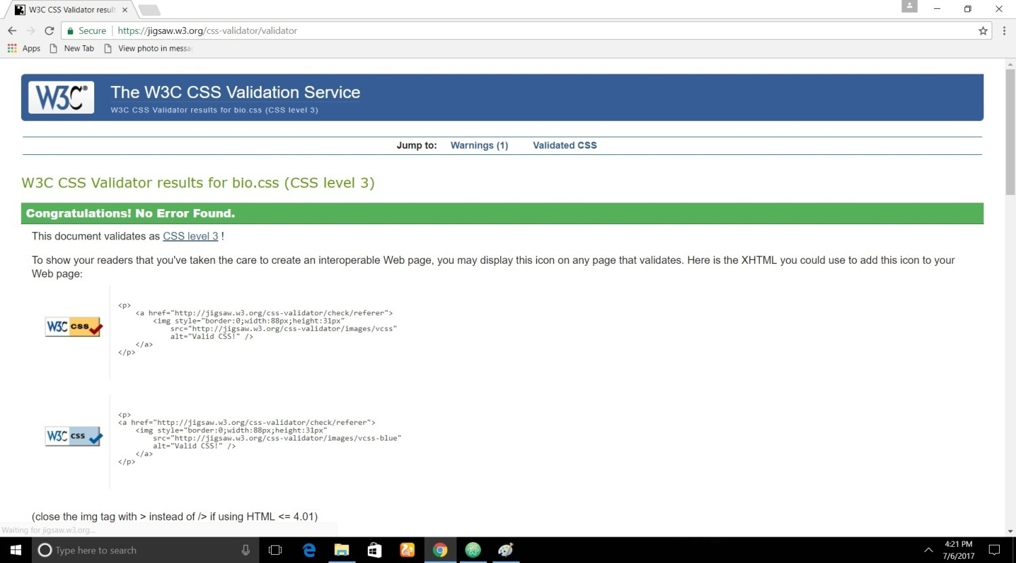

***CONTACT.HTML VALIDATOR***

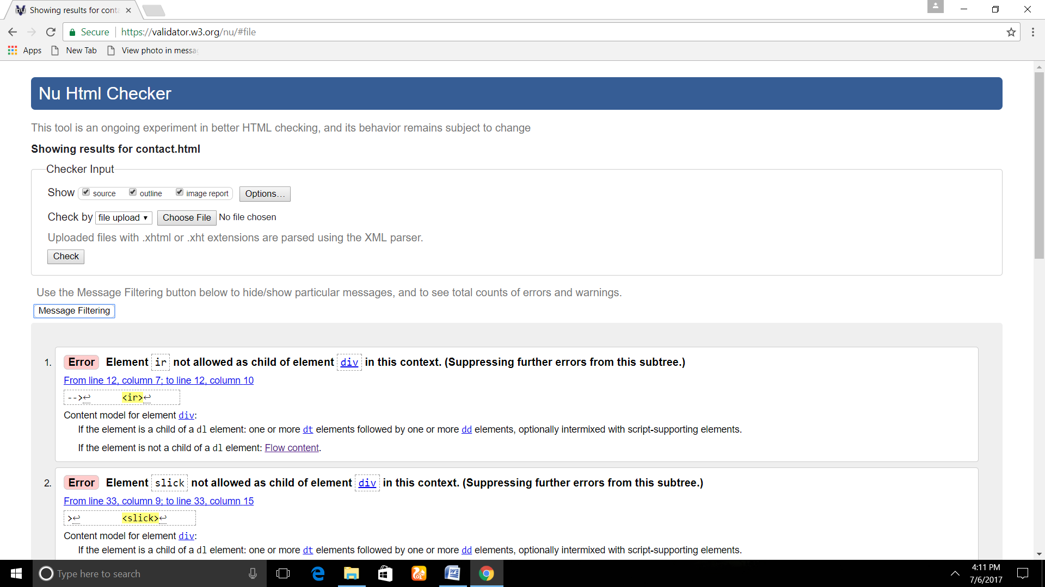

***CONTACT.CSS VALIDATOR***

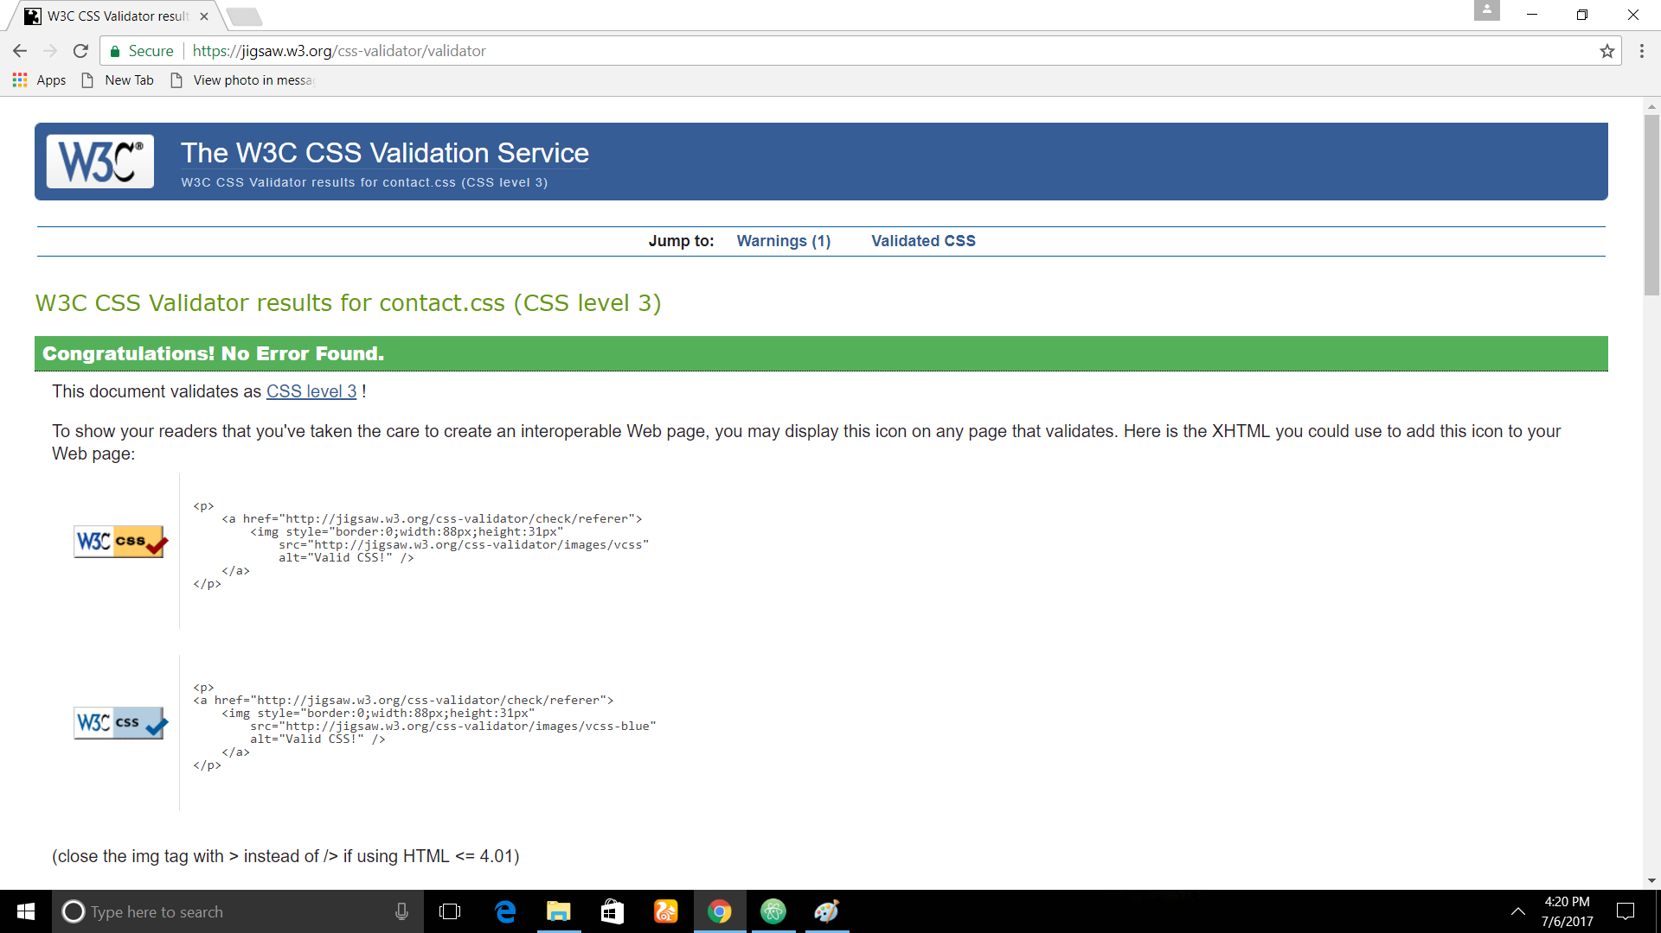

**TIME FACTOR AND LIMITATIONS**

***TIME ESTIMATED TO COMPLETE ASSSIGNMENT- 10-12 HOURS***

***COMPLETED IN- APPROX 16 HOURS***

SINCE THIS WAS A RESIT, THE TIME THAT TOOK ME TO COMPLETE ASSIGNMENT WAS SOMEHOW LESSER THAN FIRST PART OF ASSIGNMENT. THE RESIT PART INCREASED MORE OF THE KNOWLEDGE IN HTML AND CSS WORLD. SOME SUPPORTS FROM YOUTUBE AND STACK OVERFLOW WERE TAKEN TO COMPLETE THIS ASSIGNMENT.

CERTAIN RESPONSIVE FEATURES AND LINKS TO GITHUB WITH VALIDATION HAS BEEN ADDED IN THIS ASSSIGNMENT WHICH WAS INCOMPLETE THE LAST TIME. THE BELOW IMAGE SHOWS THE COMMITS DONE IN A REPOSITORY ***csy1018re***.

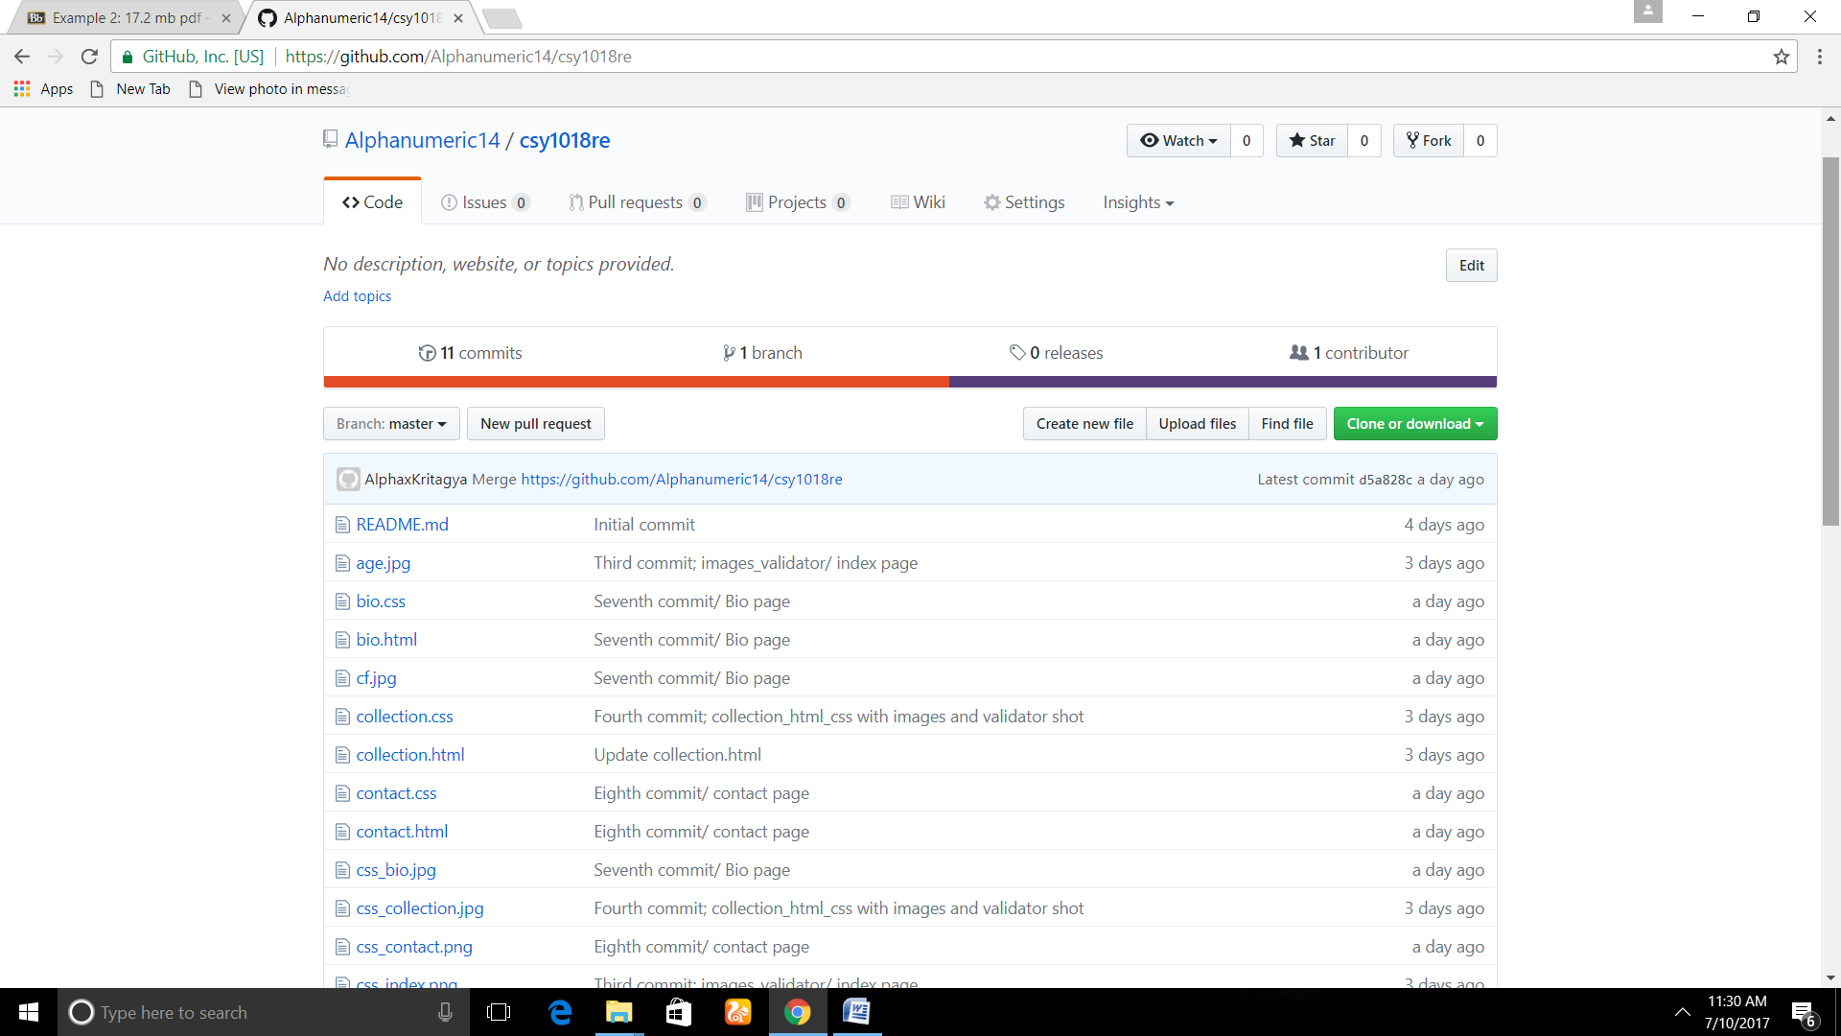

DESPITE ADDED FEATURES, SOME ERRORS OCCURRED WHILE VALIDATING HTML FILES. THE ERROR LIED IN A CHILD AND PARENT CONTEXT. BUT DEBUGGING THE WHOLE CODE WAS A WORSE DECISION TO MAKE RATHER THAN GOING AGAINST THE HTML5 FORMAT. PROVOKING SELF PERSPECTIVE WAS A TRUE DECISION FOR ME RATHER THAN FOLLOWING ALL OF THE STANZA ONE DEPARTMENT CARRIED.

**CONCLUSION**

THIS PART OF ASSIGNMENT PROVED TO BE SOMEHOW HELPFUL AND SOMEHOW NOT. CORRECTING MISSING ASPECTS IN TERM FIRST WOULD BE A BEST WAY TO MINIMISE MINUSES RATHER THAN SUBMITTING WHOLE PART OF ASSIGNMENT. BUT LOOKING AT GOOD ASPECTS STUDENTS ARE MORE CONFIDENT AND WILL HAVE A GOOD CAPABILITY IN HTML AND CSS WORLD.